**Schema (Q1 to Q5):** Employees (employee_id, firstname, lastname, email, phoneno, jobid, managerid, salary, commissionpercent, deptid);

Q1: Insert data with employee id from 155 to 170.

Ans:

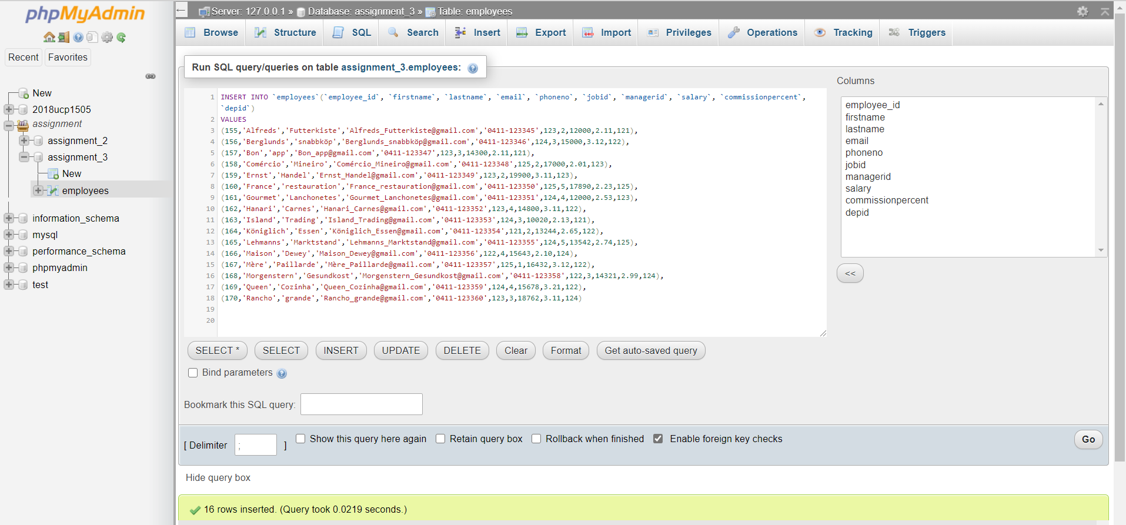Query for the Problem:

Result of the Query:

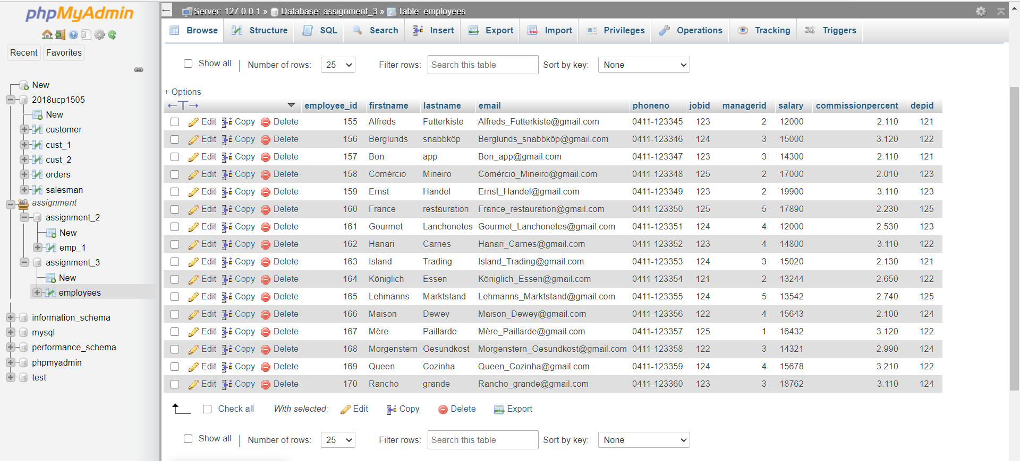

Q2: Write a query to display the name (first name and last name) for those employees who gets more salary than the employee whose ID is 163.

Ans:

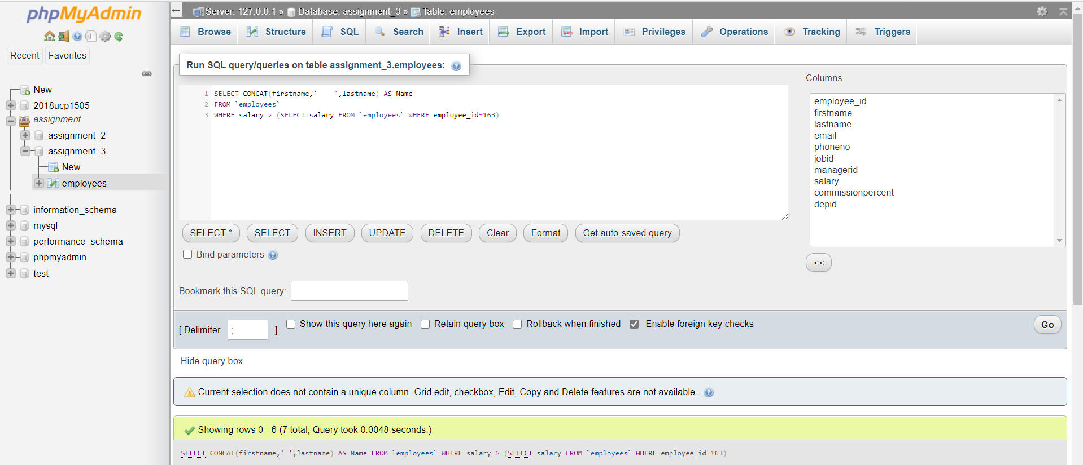 Query for the Problem:

Result of the Query:

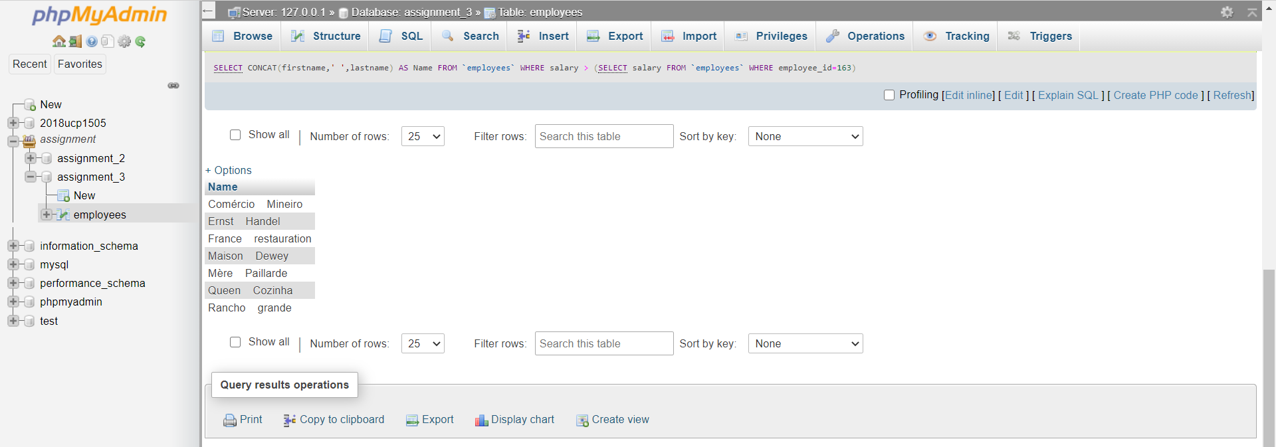

Q3: Write a query to display the name (first name and last name), salary, department id, job id for those employees who work in the same designation as the employee whose id is 169.

Ans:

Query for the Problem:

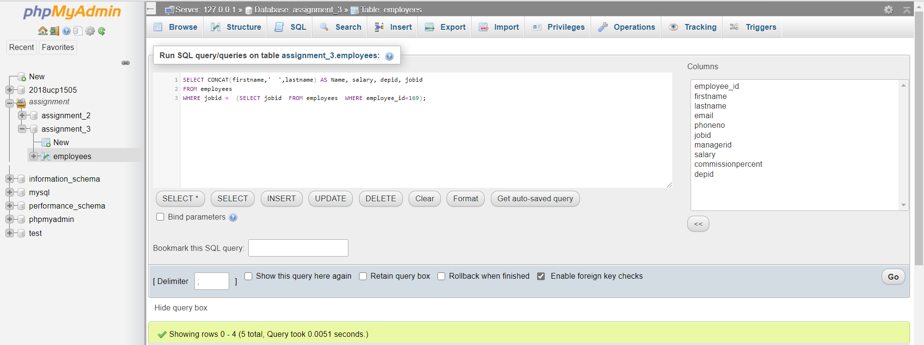

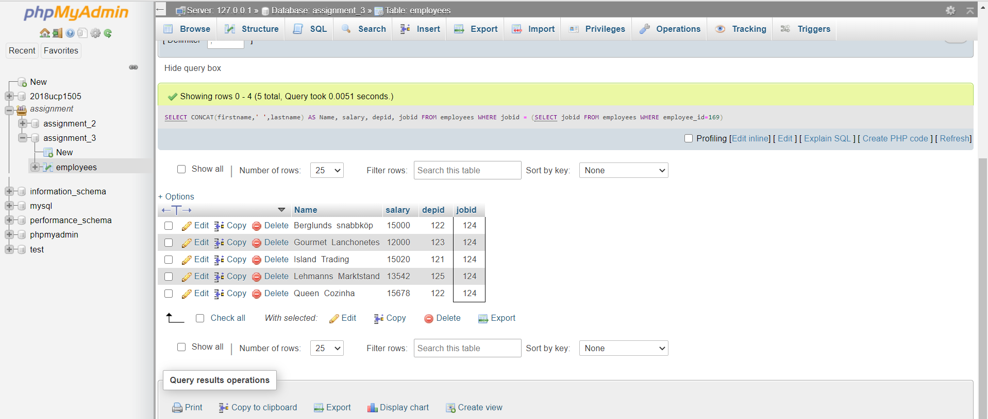Result of the Query:

Q4: Write a query to display all the information of an employee whose reporting person id is 161 and 162 respectively.

Ans:

Query for the Problem: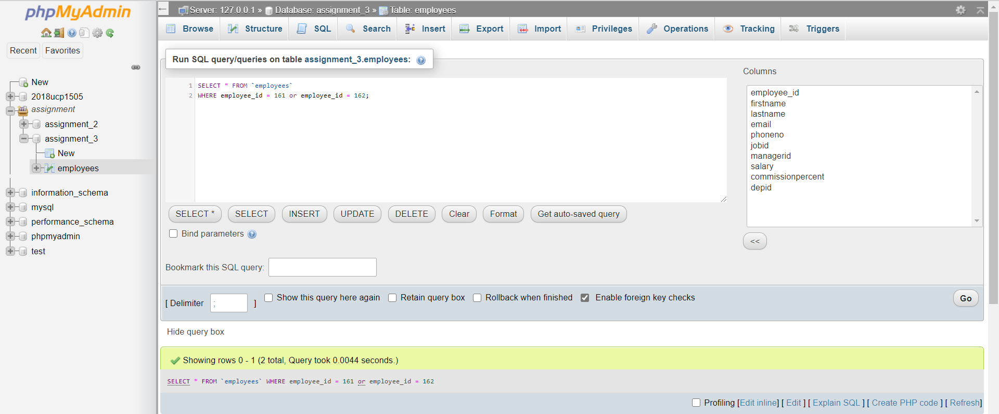

Result of the Query:

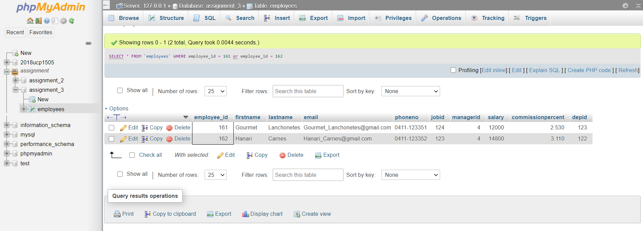

Q5: Write a query to display all the information of the employees whose salary is within the range of smallest salary and 2500.

Ans:

Query for the Problem:

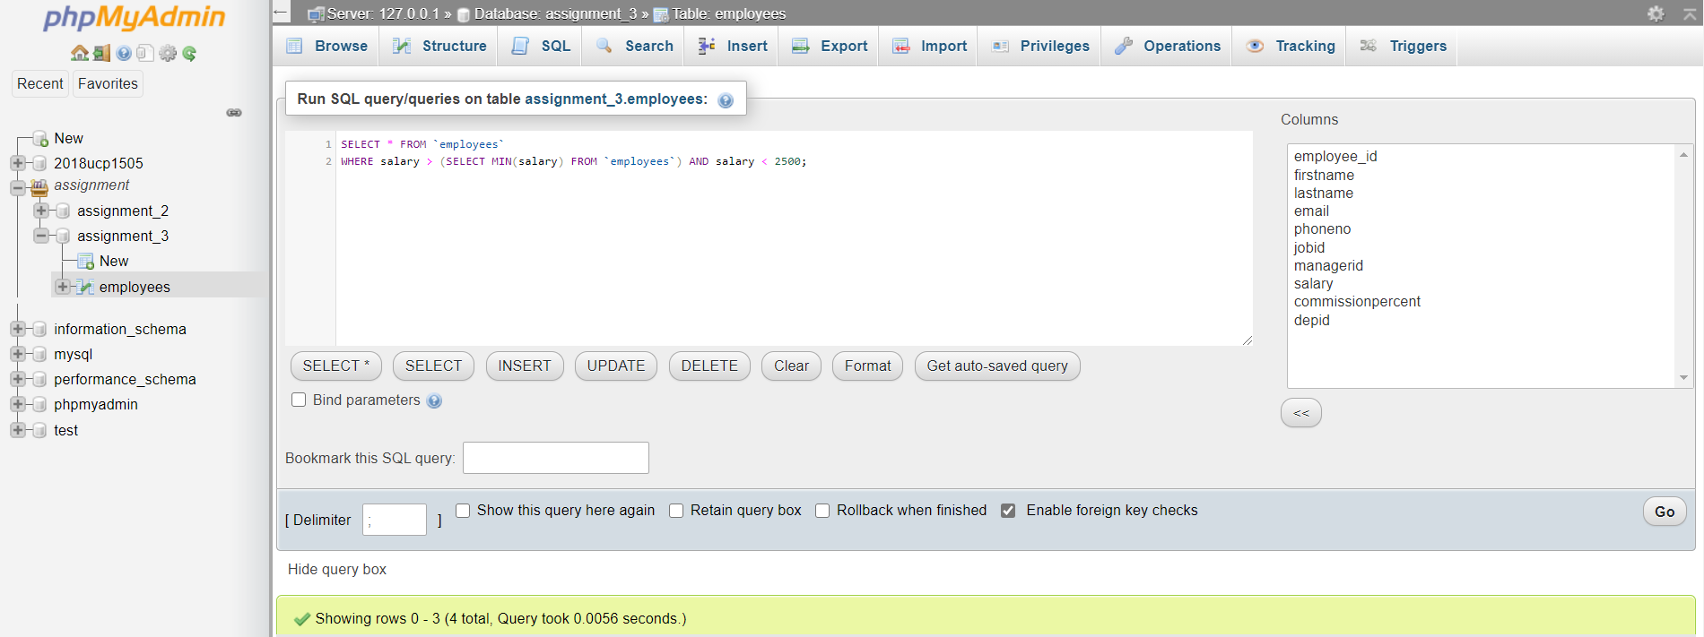

Result of the Query:

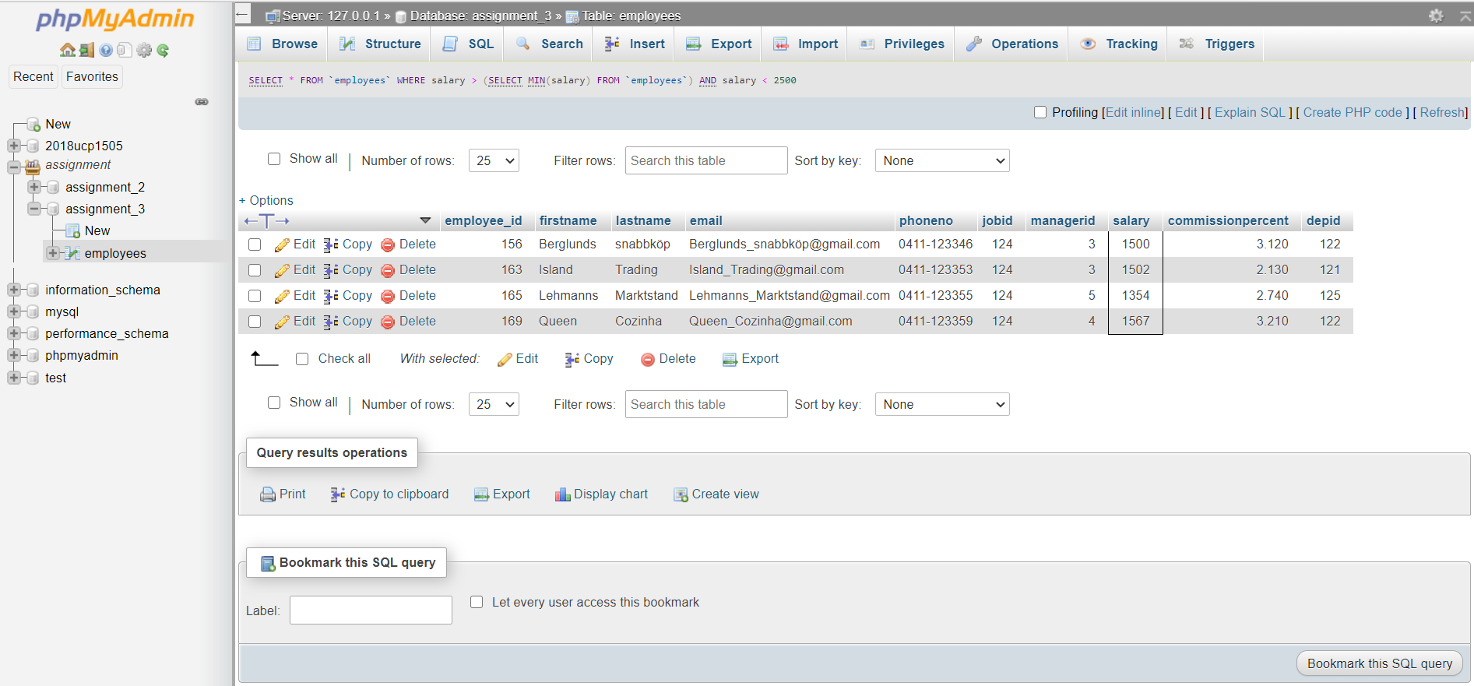

**Schema (Q6 to Q10):**

    Salesman (id,name,city,commission);

    Customer(srno,name,city,grade,sales_id);

    Orders(no,amount,date,cust_id,sales_id);

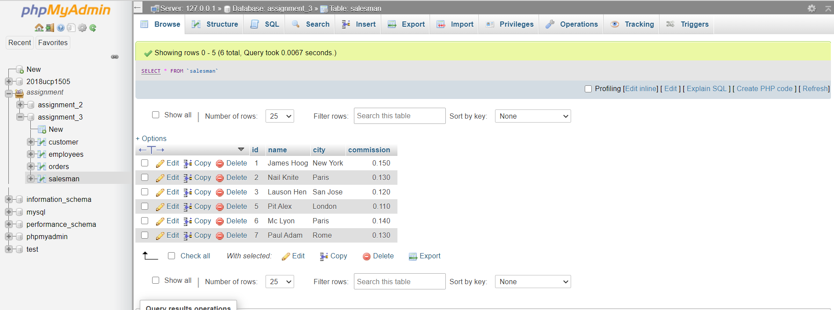Salesman Table:

Customers Table:

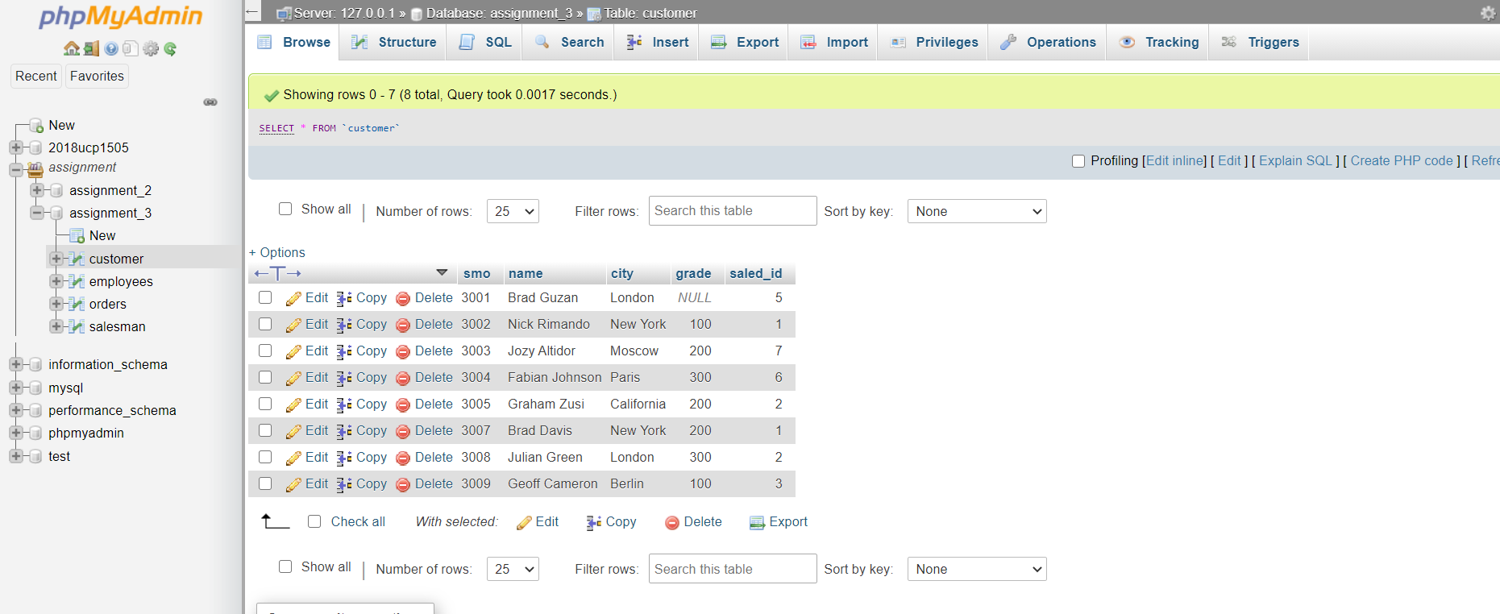

Order Table:

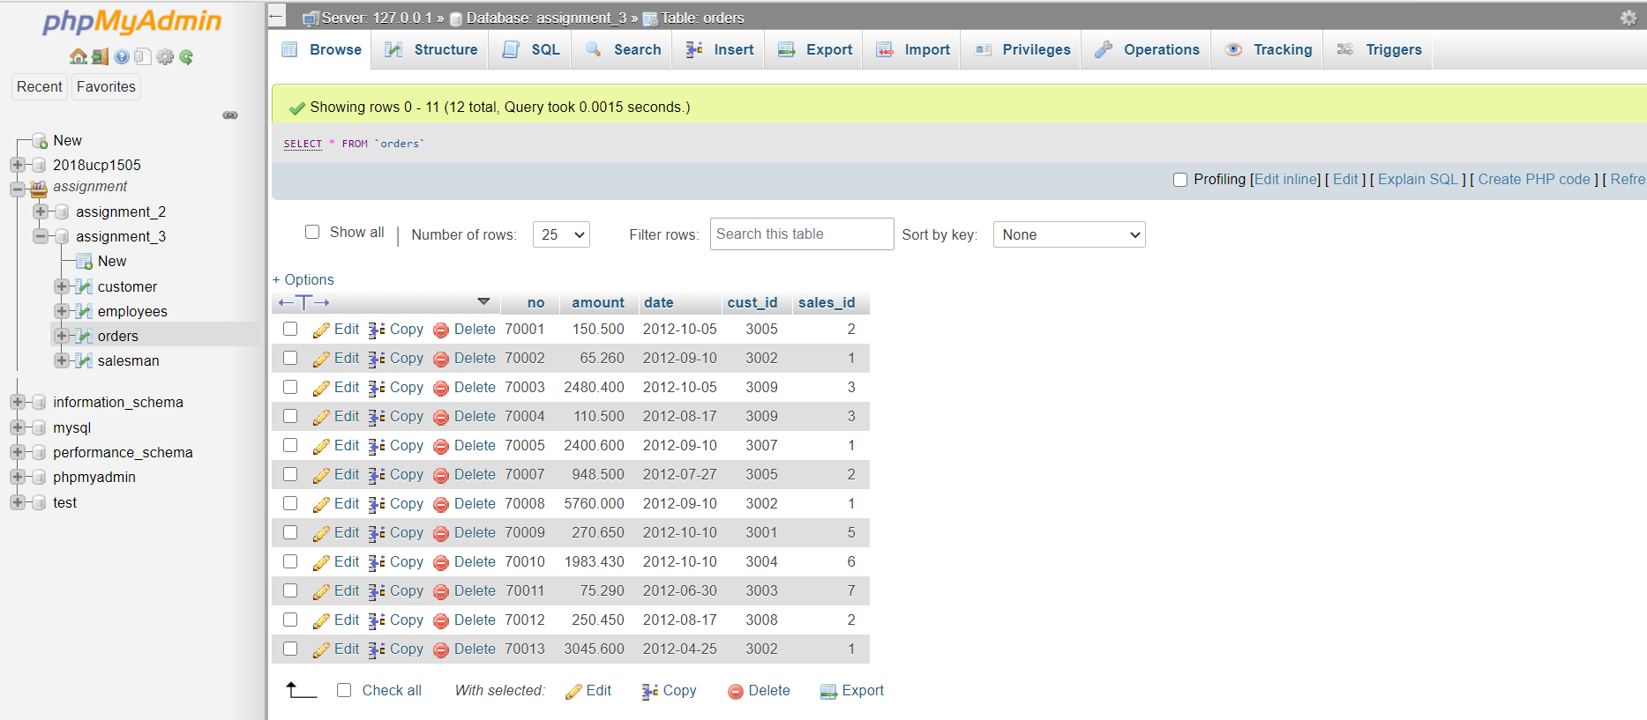

Q6: List the customers with multiple orders in 5-day period.

Ans:

Query for the Problem:

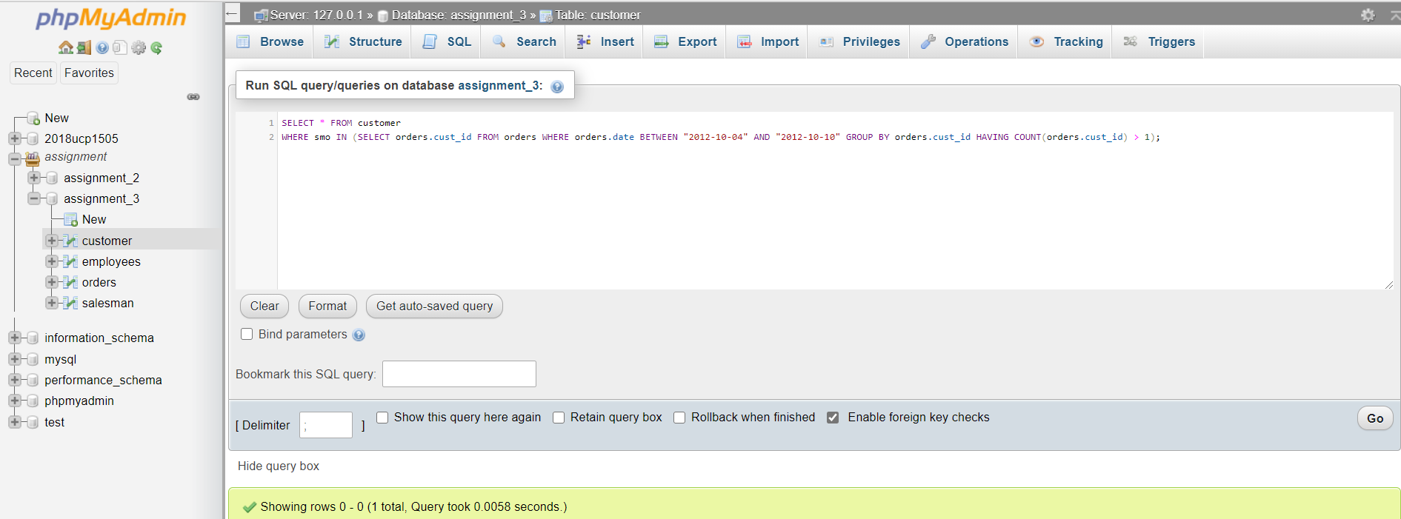

Result of the Query:

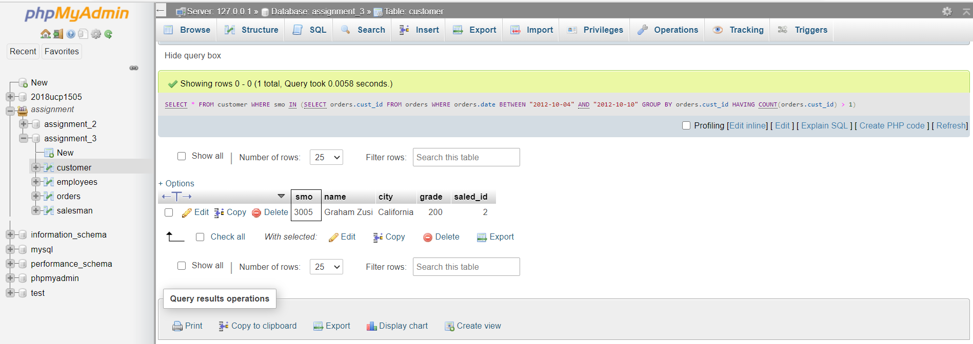

Q7: List the first order from each country.

Ans:

Query for the problem:

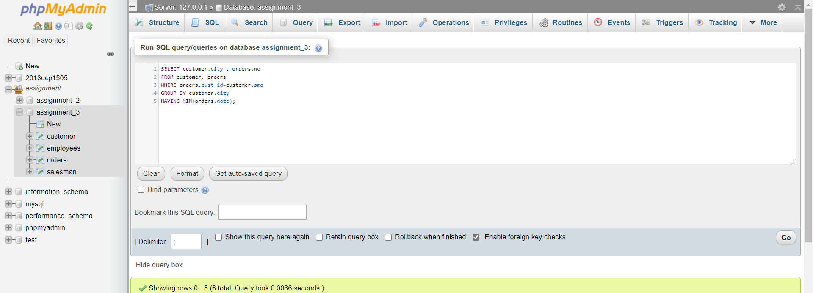

Result of the Query:

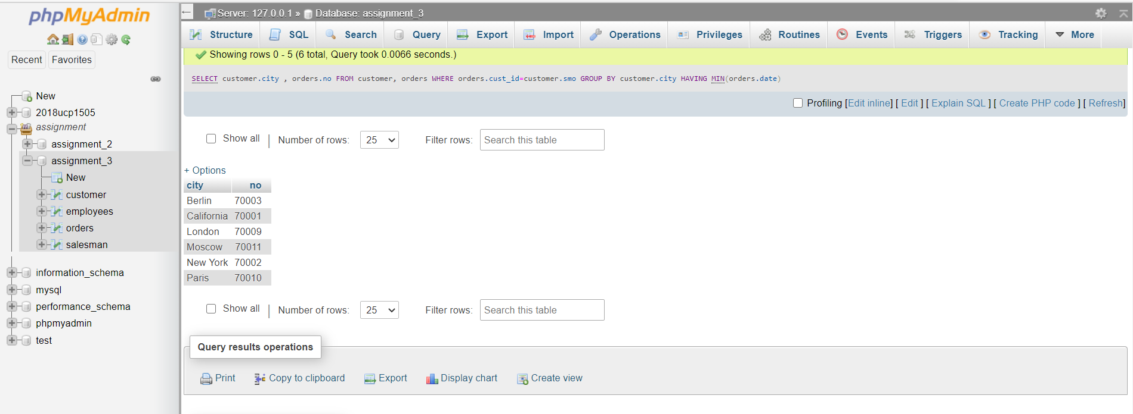

Q8: Show all orders made on the last day of the month.

Ans:

Query for the Problem:

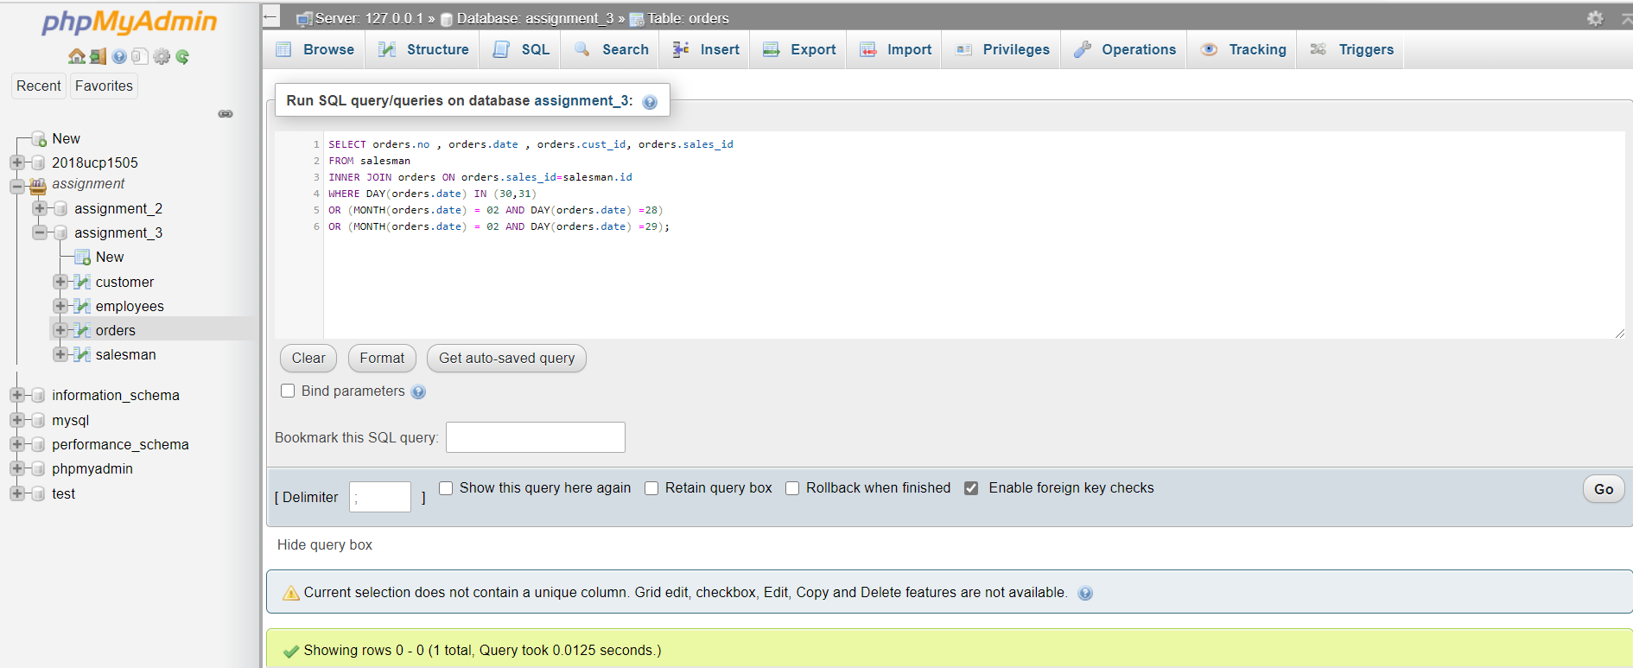

Result of the Query:

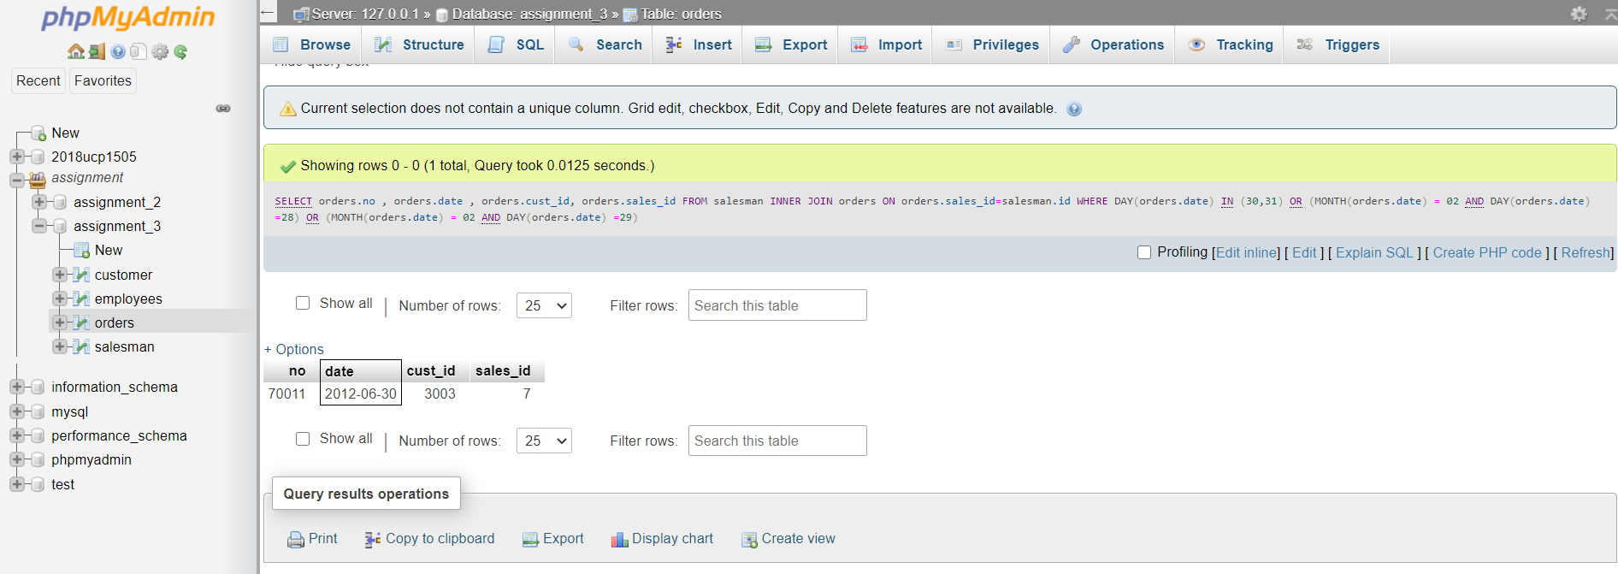

Q9: Find the customer with the highest number of orders in each city.

Ans:

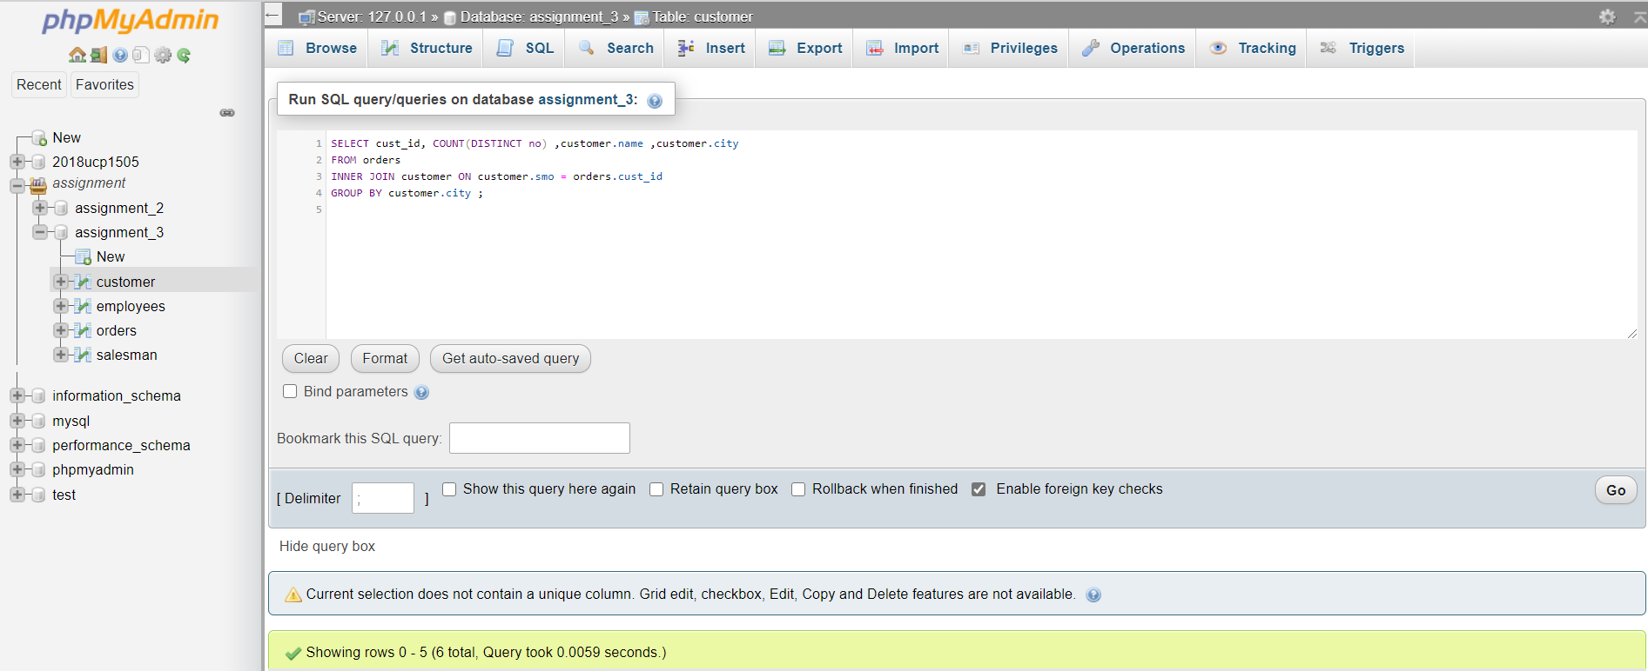Query for the Problem:

Result of the Query:

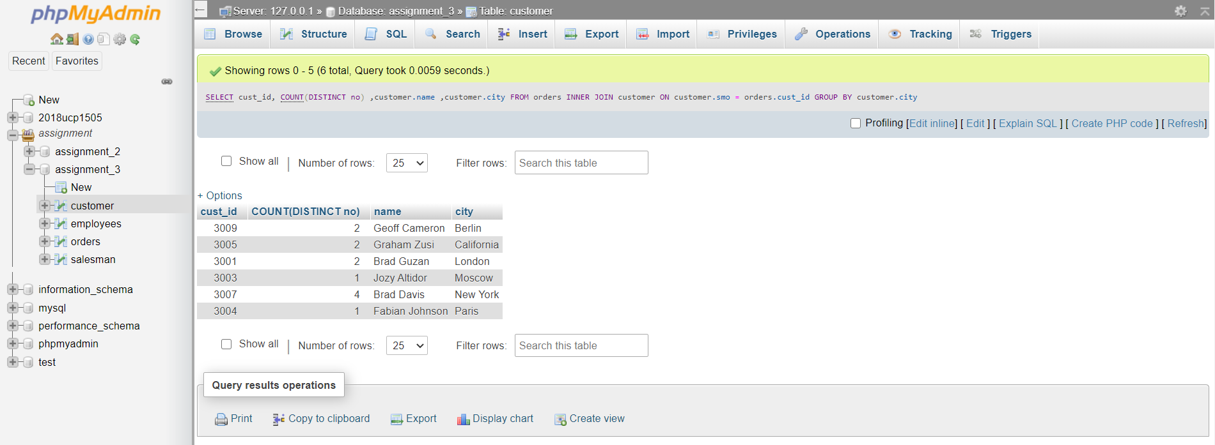

Q10: For each salesman, list the customers who have not ordered from him.

Ans:

Query for the Problem:

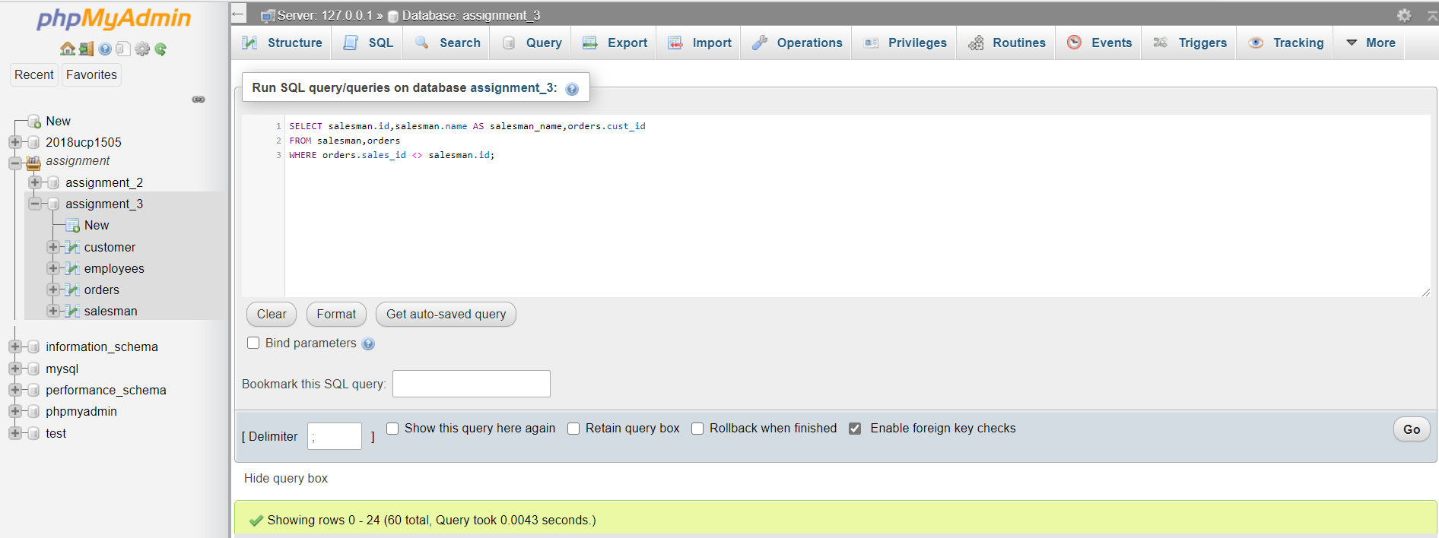

Result of the Query:

